

BICT.Honours in Information & Communication Technology

ICT1222 (P) Database Management Systems Practicum

Level 1- Semester 2 | 2022

Lecturer : Ms. Malsha

**Practical 7 Part-A,B**

Name : H.P.G.L.P. Jayathilake

Student No : TG/2020/749

Department of Information & Communication Technology

Faculty of Technology

University of Ruhuna, Sri Lanka.

FACULTY OF TECHNOLOGY

UNIVERSITY OF RUHUNA

ICT1222 (P) Database Management Systems Practicum

**Practical 7**  **Part-A,B** Level 1- Semester 2 | 2022

Student No: **TG/2020/749**

Student Name: **H.P.G. Lahiru Prasad Jayathilake**

**Part-A**

1. 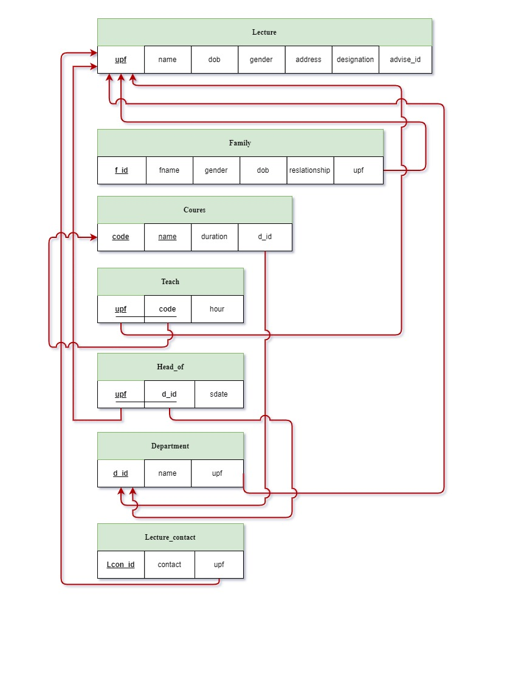
2. 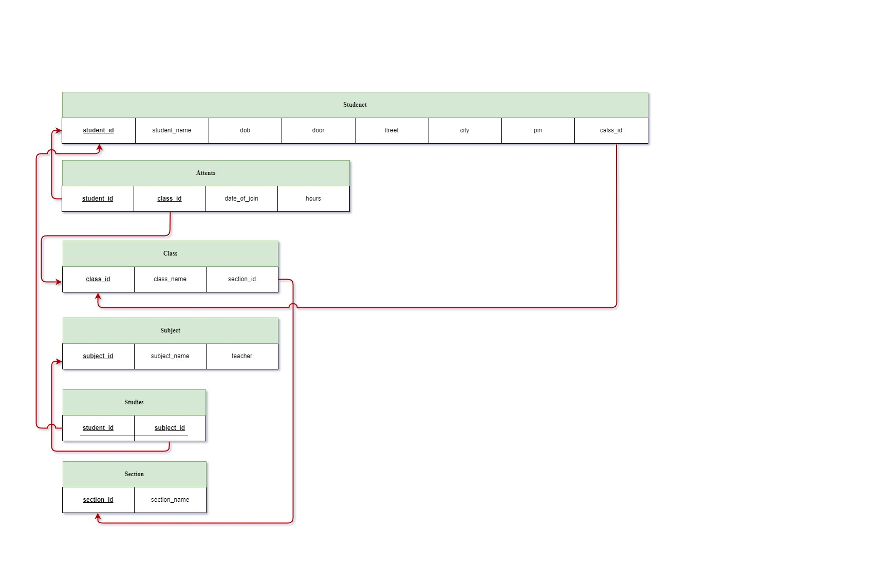

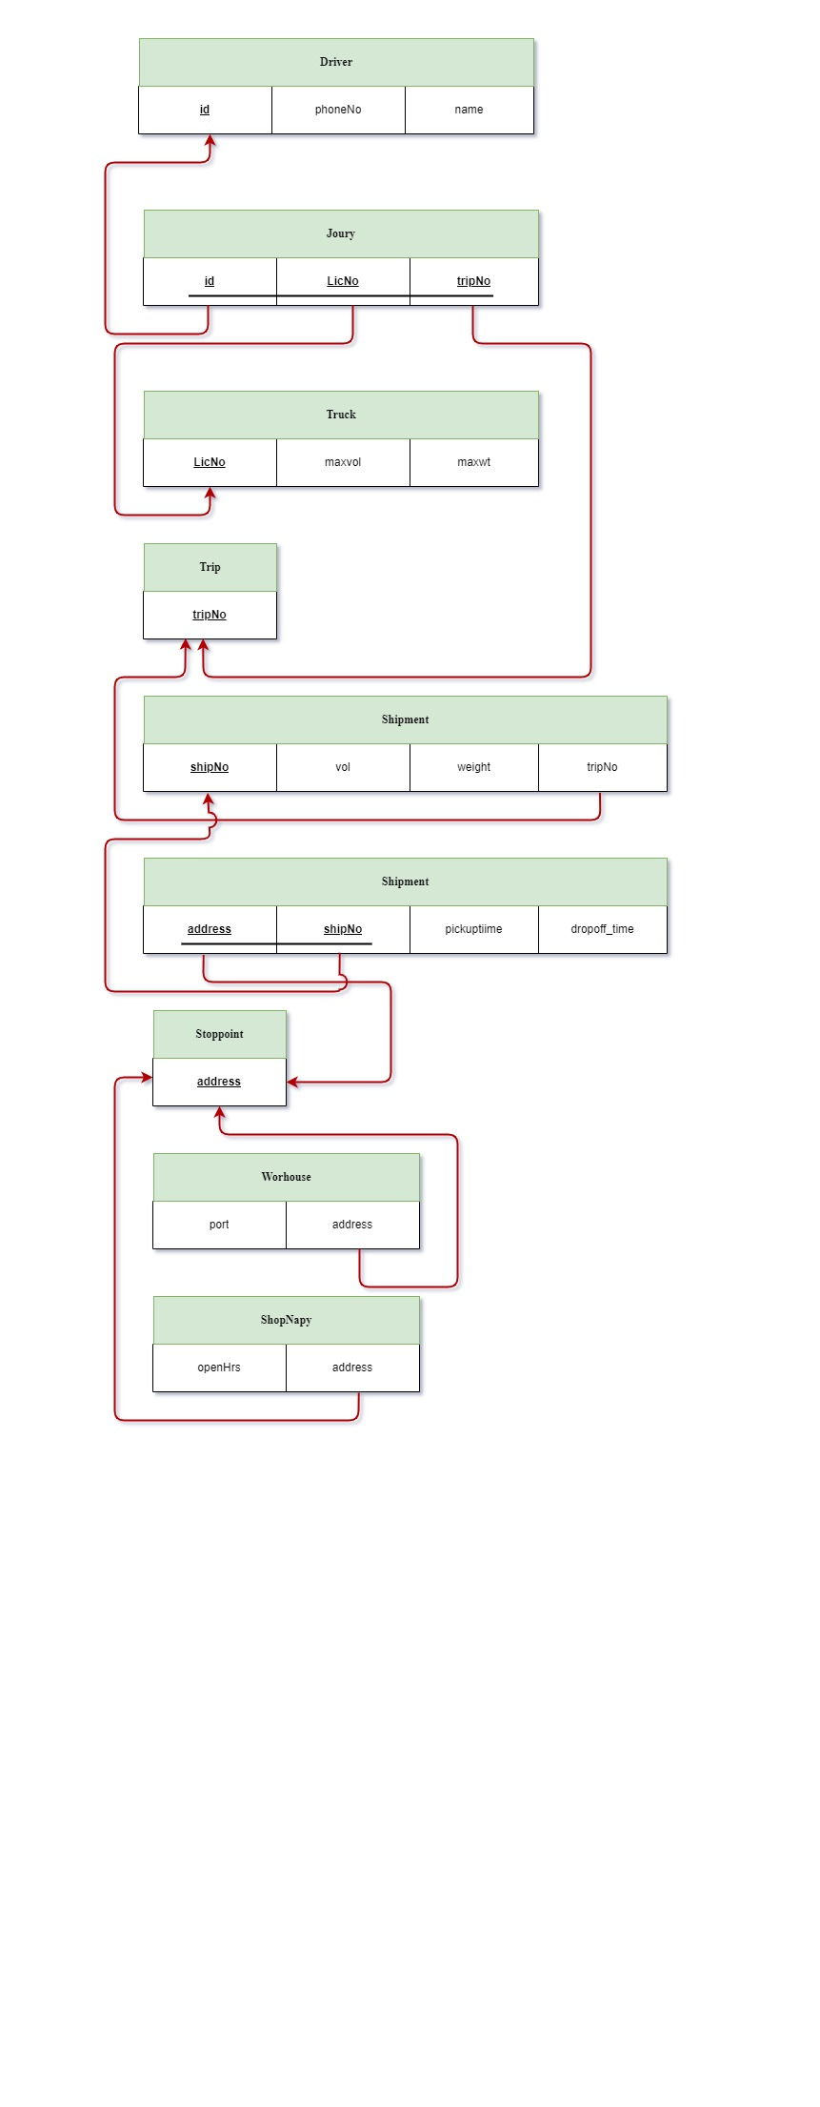

**4.ER**

**4. Relational schema**

**Part-B**

CREATE DATABASE practical07_B;

USE practical07_B;

CREATE TABLE EMPLOYEE (

EMPLOYEE_ID INT PRIMARY KEY,

FIRST_NAME VARCHAR(20),

LAST_NAME VARCHAR(20),

EMAIL VARCHAR(40),

PHONE_NUMBER VARCHAR(20),

HIRE_DATE DATE,

JOB_ID VARCHAR(10),

SALARY DECIMAL(8,2),

COMMISSION_PCT DECIMAL(6,2),

MANAGER_ID INT,

DEPARTMENT_ID INT);

CREATE TABLE CUST (

CUST_CODE VARCHAR(10) PRIMARY KEY,

CUST_NAME VARCHAR(20),

CUST_CITY VARCHAR(20),

WORKING_AREA VARCHAR(20),

CUST_COUNTRY VARCHAR(20),

GRADE INT,

OPENING_AMT DECIMAL(8,2),

RECEIVE_AMT DECIMAL(8,2),

PAYMENT_AMT DECIMAL(8,2),

OUTSTANDING_AMT DECIMAL(8,2),

PHONE_NO VARCHAR(15),

AGENT_CODE VARCHAR(10)

);

CREATE TABLE SALESMAN (

SALESMAN_ID INT PRIMARY KEY,

NAME VARCHAR(30),

CITY VARCHAR(20),

COMMISSION DECIMAL(4,4)

);

CREATE TABLE CUSTOMER (

CUSTOMER_ID INT PRIMARY KEY,

CUST_NAME VARCHAR(30),

CITY VARCHAR(20),

GRADE INT,

SALESMAN_ID INT,

FOREIGN KEY(SALESMAN_ID) REFERENCES SALESMAN(SALESMAN_ID)

);

INSERT INTO EMPLOYEE(EMPLOYEE_ID,FIRST_NAME,LAST_NAME,EMAIL,PHONE_NUMBER,HIRE_DATE,JOB_ID,SALARY,COMMISSION_PCT,MANAGER_ID,DEPARTMENT_ID)

VALUES

(100,"Steven","King","SKING","515.123.4567","1987-06-17","AD_PRES",24000.00,0.00,0,90),

(101,"Neena","Kochhar","NKOCHHAR","515.123.4568","1987-06-18","AD_VP",17000.00,0.00,100,90),

(102,"Lex","De Haan","LDEHAAN","515.123.4569","1987-06-19","AD_VP",17000.00,0.00,100,90),

(103,"Alexander","Hunold","AHUNOLD","590.423.4567","1987-06-20","IT_PROG",9000.00,0.00,102,60),

(104,"Bruce","Ernst","BERNST","590.423.4568","1987-06-21","IT_PROG",6000.00,0.00,103,60),

(105,"David","Austin","DAUSTIN","590.423.4569","1987-06-22","IT_PROG",4800.00,0.00,103,60),

(106,"Valli","Pataballa","VPATABAL","590.423.4560","1987-06-23","IT_PROG",4800.00,0.00,103,60),

(107,"Diana","Lorentz","DLORENTZ","590.423.5567","1987-06-24","IT_PROG",4200.00,0.00,103,60);

INSERT INTO CUST (CUST_CODE,CUST_NAME,CUST_CITY,WORKING_AREA,CUST_COUNTRY,GRADE,OPENING_AMT,RECEIVE_AMT,PAYMENT_AMT,OUTSTANDING_AMT,PHONE_NO,AGENT_CODE)

VALUES

('C00013','Holmes','London','London','UK',2,6000.00,5000.00,7000.00,4000.00,'BBBBBBB','A003'),

('C00001','Micheal','New York','New York','USA',2,3000.00,5000.00,2000.00,6000.00,'CCCCCCC','A008'),

('C00020','Albert','New York','New York','USA',3,5000.00,7000.00,6000.00,6000.00,'BBBBSBB','A008'),

('C00025','Ravindran','Bangalore','Bangalore','India',2,5000.00,7000.00,4000.00,8000.00,'AVAVAVA','A011'),

('C00024','Cook','London','London','UK',2,4000.00,9000.00,7000.00,6000.00,'FSDDSDF','A006'),

('C00015','Stuart','London','London','UK',1,6000.00,8000.00,3000.00,11000.00,'GFSGERS','A003'),

('C00002','Bolt','New York','New York','USA',3,5000.00,7000.00,9000.00,3000.00,'DDNRDRH','A008'),

('C00018','Fleming','Brisban','Brisban','Australia',2,7000.00,7000.00,9000.00,5000.00,'NHBGVFC','A005'),

('C00021','Jacks','Brisban','Brisban','Australia',1,7000.00,7000.00,7000.00,7000.00,'WERTGDF','A005'),

('C00019','Yearannaidu','Chennai','Chennai','India',1,8000.00,7000.00,7000.00,8000.00,'ZZZZBFV','A010');

INSERT INTO SALESMAN(SALESMAN_ID,NAME,CITY,COMMISSION)

VALUES

(5001,"James Hoog","New York",0.15),

(5002,"Nail Knite","Paris",0.13),

(5005,"Pit Alex","London",0.11),

(5006,"Mc Lyon","Paris",0.14),

(5007,"Paul Adam","Rome",0.13),

(5003,"Lauson Hen","San Jose",0.12);

INSERT INTO CUSTOMER(CUSTOMER_ID,CUST_NAME,CITY,GRADE,SALESMAN_ID)

VALUES

(3002,"Nick Rimando","New York",100,5001),

(3007,"Brad Davis","New York",200,5001),

(3005,"Graham Zusi","California",200,5002),

(3008,"Julian Green","London",300,5002),

(3004,"Fabian Johnson","Paris",300,5006),

(3009,"Geoff Cameron","Berlin",100,5003),

(3003,"Jozy Altidor","Moscow",200,5007),

(3001,"Brad Guzan","London",0,5005);

UPDATE employee

SET email='not available'

WHERE email IS NOT NULL;

UPDATE employee

SET email='not available', COMMISSION_PCT='0.10'

WHERE email IS NOT NULL;

UPDATE employee

SET email='not available', COMMISSION_PCT='0.10'

WHERE DEPARTMENT_ID=110;

UPDATE employee

SET email='not available'

WHERE department_id=80 AND COMMISSION_PCT<0.20;

UPDATE employee

SET email='not available'

WHERE department_id=90;

UPDATE employee

SET SALARY=8000.00

WHERE EMPLOYEE_ID=105 AND salary < 5000.00;

SELECT first_name, last_name, department_id

FROM employee

WHERE Department_id=30 OR Department_id=100

ORDER BY department_id ASC;

SELECT concat(first_name, last_name)

FROM employee

WHERE hire_date BETWEEN '1987-01-31' AND '1987-12-31';

SELECT job_id

FROM Employee

ORDER BY job_id DESC;

SELECT CONCAT(FIRST_NAME,LAST_NAME) AS name,salary, salary*15/100 AS PF

FROM Employee

ORDER BY CONCAT(first_name,last_name) ASC;

SELECT last_name

FROM employee

WHERE last_name LIKE '__e%';

SELECT cust_city,SUM(opening_amt),

AVG(receive_amt),

MAX(payment_amt)

FROM cust

WHERE grade=2 GROUP BY cust_city HAVING AVG(receive_amt) > 500.00 ORDER BY SUM(opening_amt);

SELECT cust_country,COUNT(cust_name)

FROM cust

GROUP BY GRADE HAVING COUNT(cust_name) > 2;

SELECT customer.cust_name,customer.city,salesman.name,salesman.commission

FROM customer

INNER JOIN salesman ON customer.salesman_id=salesman.salesman_id;

SELECT customer.cust_name, customer.city, salesman.name , salesman.commission

FROM customer

INNER JOIN salesman ON customer.salesman_id=salesman.salesman_id

WHERE salesman.commission>12;

SELECT customer.cust_name,customer.city,salesman.name,salesman.city,salesman.commission

FROM customer

INNER JOIN salesman ON customer.salesman_id=salesman.salesman_id

WHERE salesman.commission > 12 AND customer.city<>salesman.city;

SELECT customer.cust_name,customer.city,customer.grade,salesman.name ,salesman.city

FROM customer

INNER JOIN salesman ON customer.salesman_id=salesman.salesman_id

ORDER BY customer.customer_id ASC;

SELECT customer.cust_name,customer.city ,customer.grade,salesman.name ,salesman.city

FROM customer

INNER JOIN salesman ON customer.salesman_id=salesman.salesman_id

WHERE customer.grade < 300

ORDER BY customer.customer_id ASC;

SELECT customer.cust_name,customer.city,customer.grade, salesman.name , salesman.city

FROM customer

RIGHT OUTER JOIN salesman ON customer.salesman_id=salesman.salesman_id

ORDER BY salesman.salesman_id;

SELECT customer.cust_name,customer.city,customer.grade, salesman.name , salesman.city

FROM customer

LEFT OUTER JOIN salesman ON salesman.salesman_id=customer.salesman_id

WHERE customer.grade < 300

ORDER BY salesman.salesman_id ASC;